|  |
| --- |
|  |
| The Specification |
| [Type the document subtitle] |
|  |
| **[Your Name]** |
| **[Pick the date]** |

[Type the abstract of the document here. The abstract is typically a short summary of the contents of the document. Type the abstract of the document here. The abstract is typically a short summary of the contents of the document.]

Table of Contents

[To update the table of contents, right click the message below and select Update Field (F9 on PC, ⌥⌘U on Mac).]

**No table of contents entries found.**

1. Pages
   1. Page Tree

Login  
index  
数据分析  
 销售数据查询  
 库存信息查询  
移动办公  
 订单管理  
 评论管理  
设置

* 1. Login
     1. User Interface

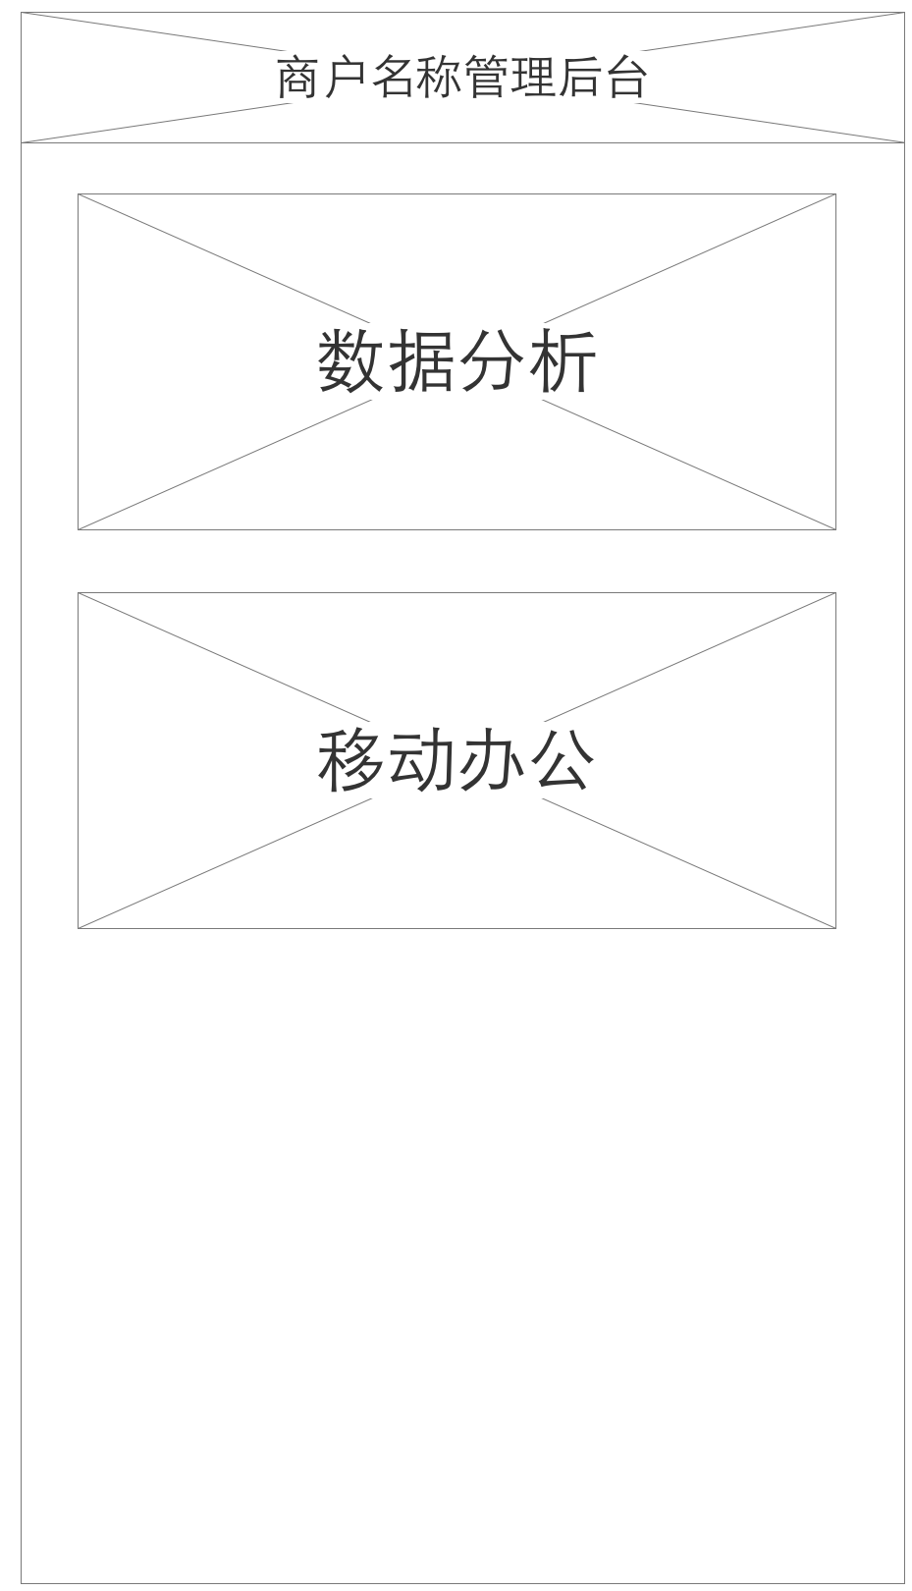

* 1. index
     1. User Interface

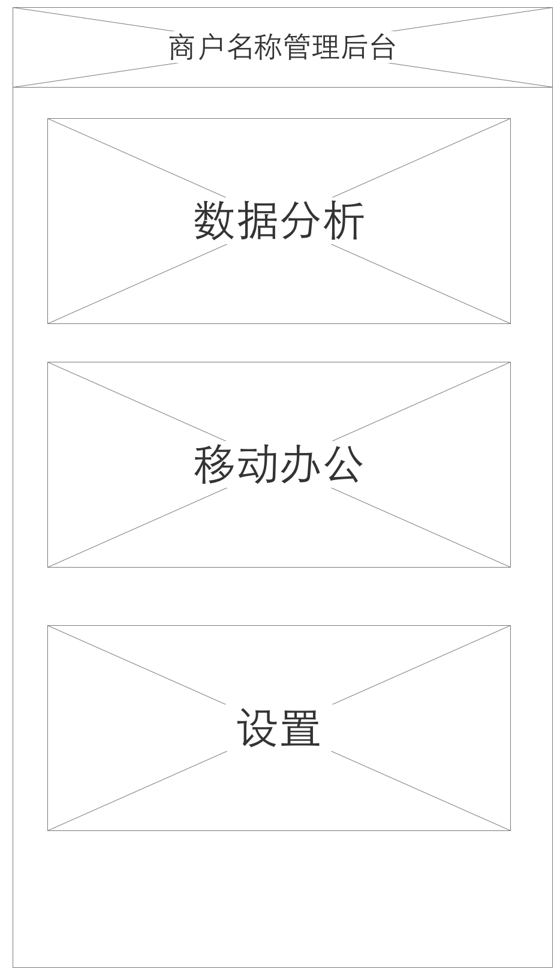

* 1. 数据分析
     1. User Interface

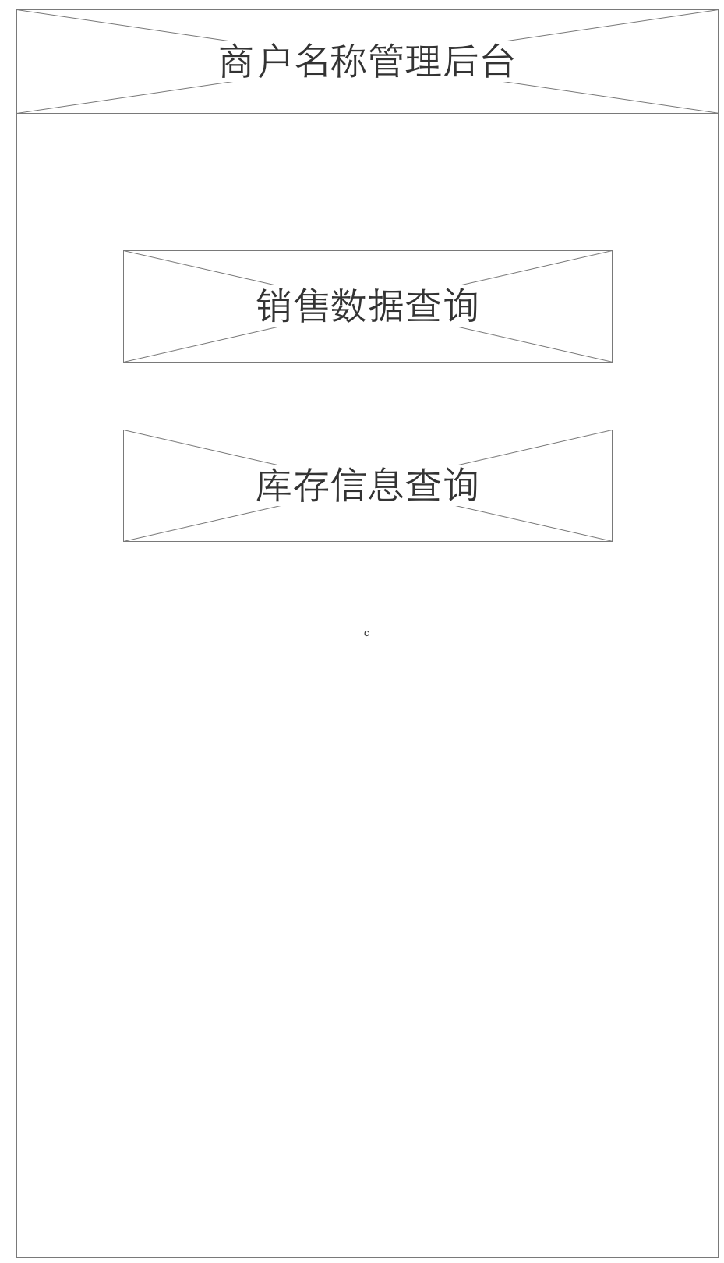

* 1. 销售数据查询
     1. User Interface

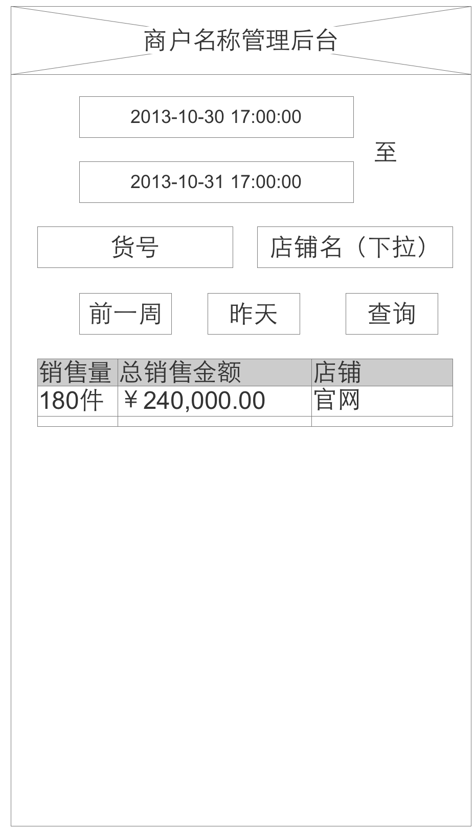

* 1. 库存信息查询
     1. User Interface

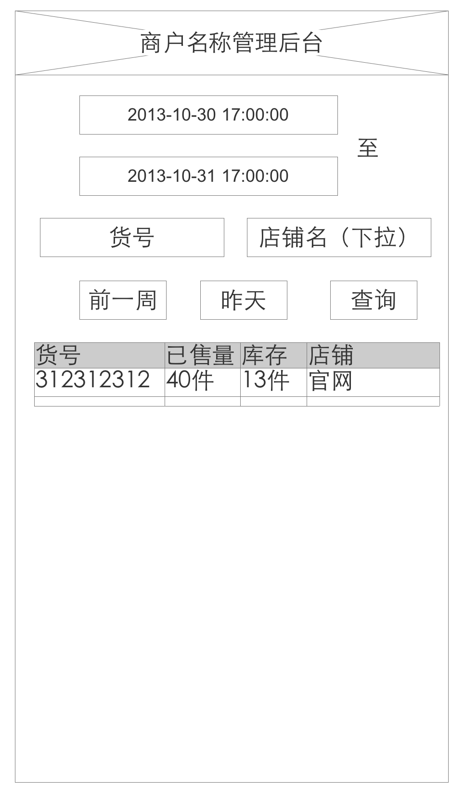

* 1. 移动办公
     1. User Interface

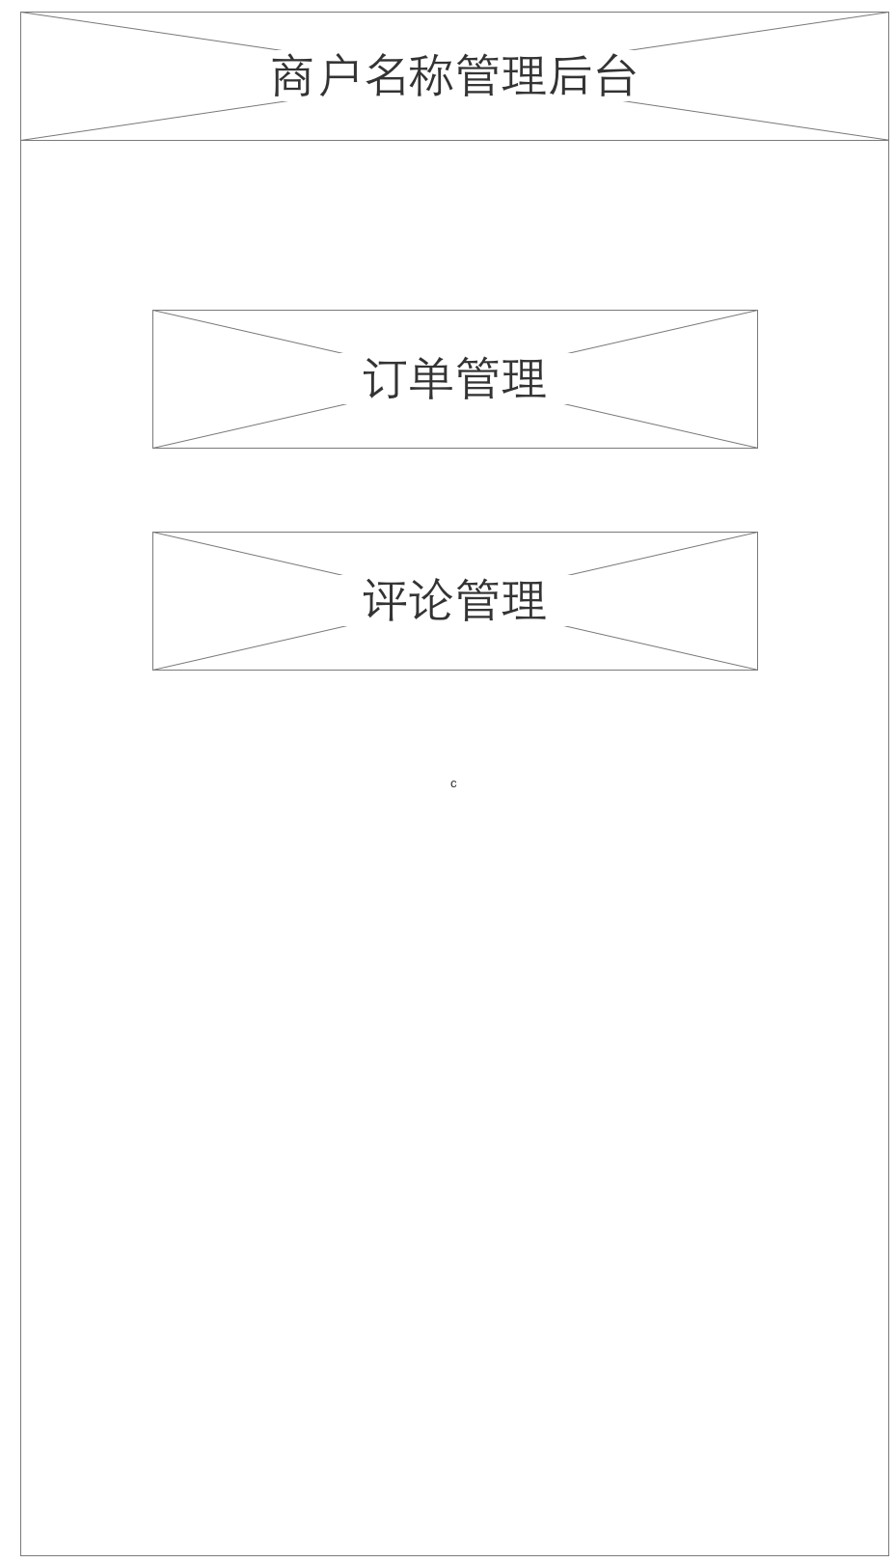

* 1. 订单管理
     1. User Interface

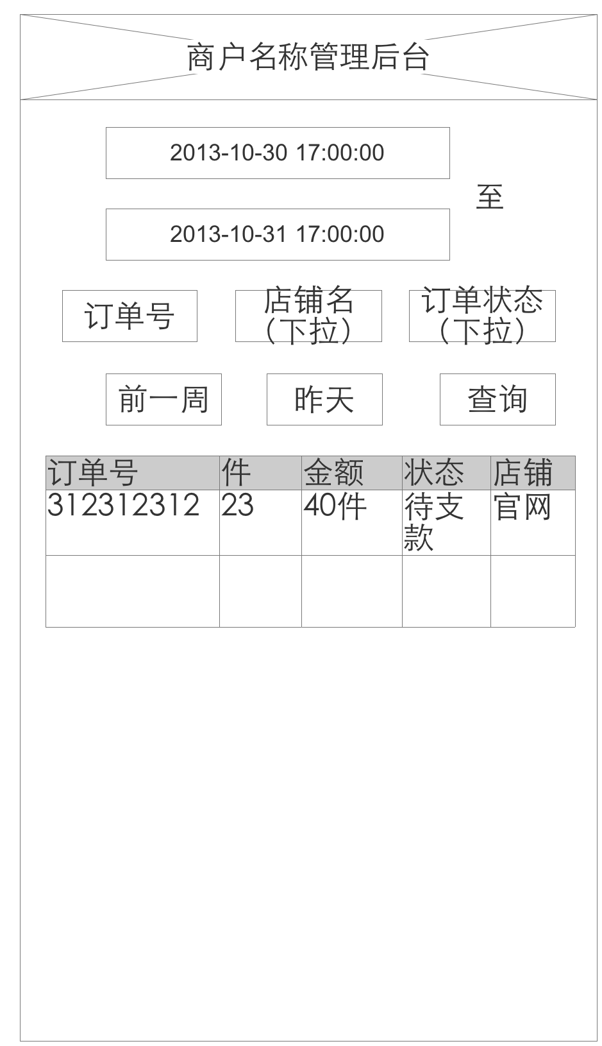

* 1. 评论管理
     1. User Interface

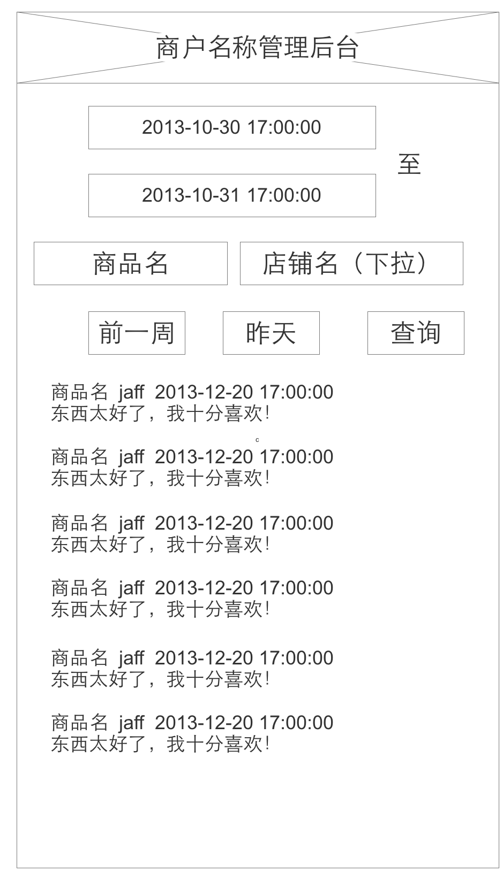

* 1. 设置
     1. User Interface

